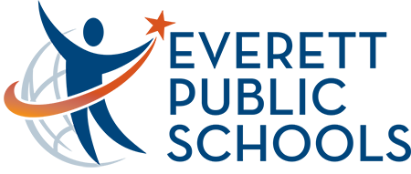 | Fall Planning 2021  May 17, 2021  Noon – 1 p.m.  Zoom

AGENDA

- Level set expectations (KR)

- Completed Items: (KR)
  - Pulse survey on interest in virtual learning: summary results
  - Communication went out Thursday May 13 stating 100% in person
  - Confirmed no attestations needed for summer school or fall 2021

- Virtual options for the fall (SB/JW)
  - Status update: here
  - Timeline for decision
  - Timeline for communication -end of June
Concern about losing students to Spokane Academy
We can brand the portal as ours
Applying ALE to OSPI this week, hope to have potential school changes in June
Jeff/Peter/Shelley/Jeanne – how urgently do we need to push the virtual piece?

- Need to have a way to support families who are in quarantine due to close contact

- Do we need a back-up ability to flex to concurrent or hybrid?

- Negotiations update and impact on fall (DK/PS/SB)

- Social distancing guidance for fall 2021 (DP/MG) this will impact all other groups
  - 2 plans created: one with 3’ distancing in classrooms and 6’ in shared areas where masks are off like cafeteria, one is no social distancing most social distancing feasible
  - DOH will provide guidance over the summer which plan to implement
Cannot let the social distancing parameter prevent 100% kids in school. “as we are able”
- Normal progress to graduation
- “To the degree possible” – we will keep the same academic offering
- “all classrooms meet with 3’ rule”
- Maximum safety protocols – operating in good faith to be safe
- Master schedule seat count to match contract numbers like done previously
- Would high schools need to consider an additional lunch? Need to explore additional areas rather than additional lunch (Regionals - work with principals to see what their needs are. Bring needs back to this group best lunch plan you can do – space and staffing factors)

- Facilities/Cleaning requirements (MR/MG)

- Communicating about planning

- Next meeting May 27

